Draw the DFD to be considered while codding the individual processes or functions.

Table of Contents
1.) Introduction 2
2.) Level 0 DFD (Context Diagram) 2
2.3) Data Flow 2
3.) Level 1 DFD (User Processes) 3
3.1) Entities 3
3.2) Processes 3
3.3) Data Flow 3
4.) Level 2 DFD (Detailed Processes) 4
4.1) Entities 4
4.2) Processes 4
4.3) Data Flow: 4
5.) DFD Diagrams 5
5.1.) Level-0 DFD 5

Introduction
Creating a Data Flow Diagram (DFD) for a software application like the Expense Analyzer App is a complex task and usually involves multiple levels of DFDs to represent the data flow within the system. I can provide you with a high-level overview of what a DFD for this type of app might look like, but keep in mind that a comprehensive DFD might require more details and levels.

Here's a simplified DFD for the Expense Analyzer App:

- Level 0 DFD (Context Diagram)
  - This is the highest-level DFD, representing the system as a single process.
  - It shows interactions between the system (the Expense Analyzer App) and external entities.

2.1.) Entities
1. User
2. Database (where expense data is stored)
3. Expense Analyzer App

2.2) Processes

- User interacts with the Expense Analyzer App to perform tasks like registration, expense entry, and reporting.
- The Expense Analyzer App communicates with the database to store and retrieve expense data.

2.3) Data Flow

- User inputs and retrieves data from the Expense Analyzer App.
- The Expense Analyzer App interacts with the database to save and retrieve expense data.

Level 1 DFD (User Processes)
- At this level, you can break down the User process into more detailed sub-processes.

3.1) Entities
1. User
2. Database
3. Expense Analyzer App

3.2) Processes
1. User Registration
2. User Login
3. Enter Expense
4. View Expense Report
5. Generate Expense Summary
6. Logout

3.3) Data Flow
    - User interacts with the Expense Analyzer App to perform specific tasks.
    - The Expense Analyzer App communicates with the database as needed to retrieve or update expense data.

Level 2 DFD (Detailed Processes)
If needed, you can further break down each user process into more detailed sub-processes. For example, the "Enter Expense" process might involve data validation, category selection, and more.

4.1) Entities
1. User
2. Database
3. Expense Analyzer App

4.2) Processes
1. User Registration
- Validate User Data
- Create User Account
2. User Login
- Verify User Credentials
- Grant Access
3. Enter Expense
- Validate Expense Data
- Categorize Expense
- Save Expense Data
4. View Expense Report
- Retrieve Expense Data
- Display Expense Report
5. Generate Expense Summary
- Calculate Expense Totals
- Generate Summary Report
6. Logout

4.3) Data Flow:
  - Each sub-process communicates with the Expense Analyzer App and may involve interactions with the database.

Please note that this is a simplified representation, and in practice, DFDs can become more complex as you delve deeper into the application's functionality and data flow. Creating a comprehensive DFD often involves collaboration with stakeholders and subject matter experts to ensure accuracy and completeness.

DFD Diagrams

5.1.) Level-0 DFD
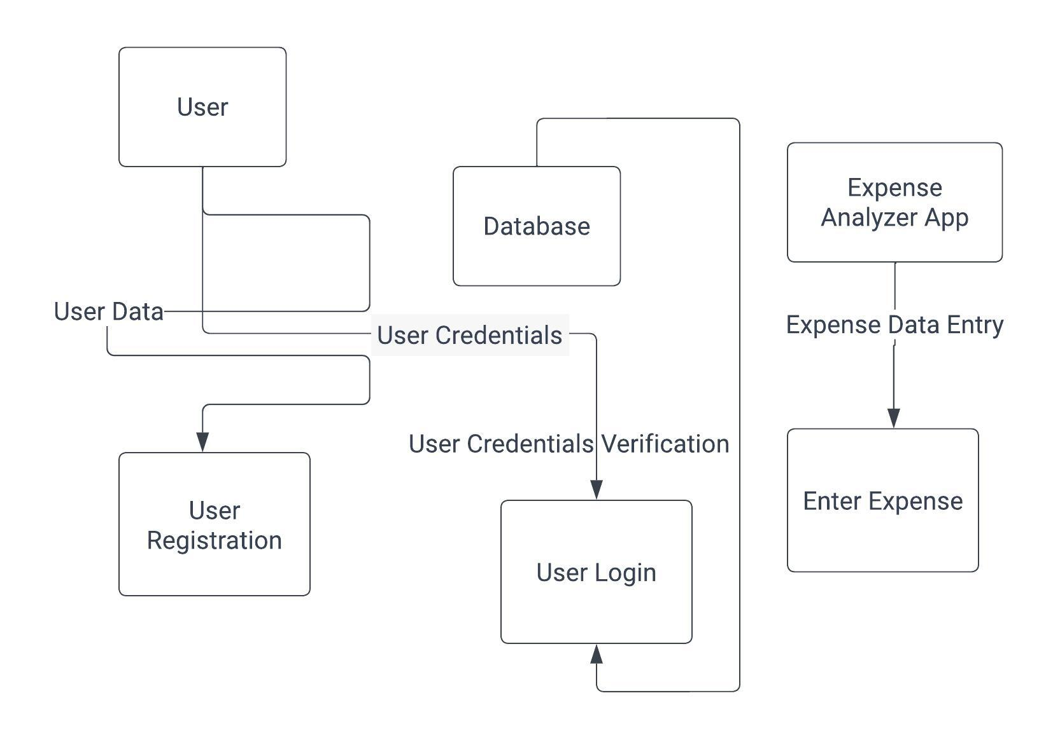
Figure 1 user login credentials and expense entered by user

